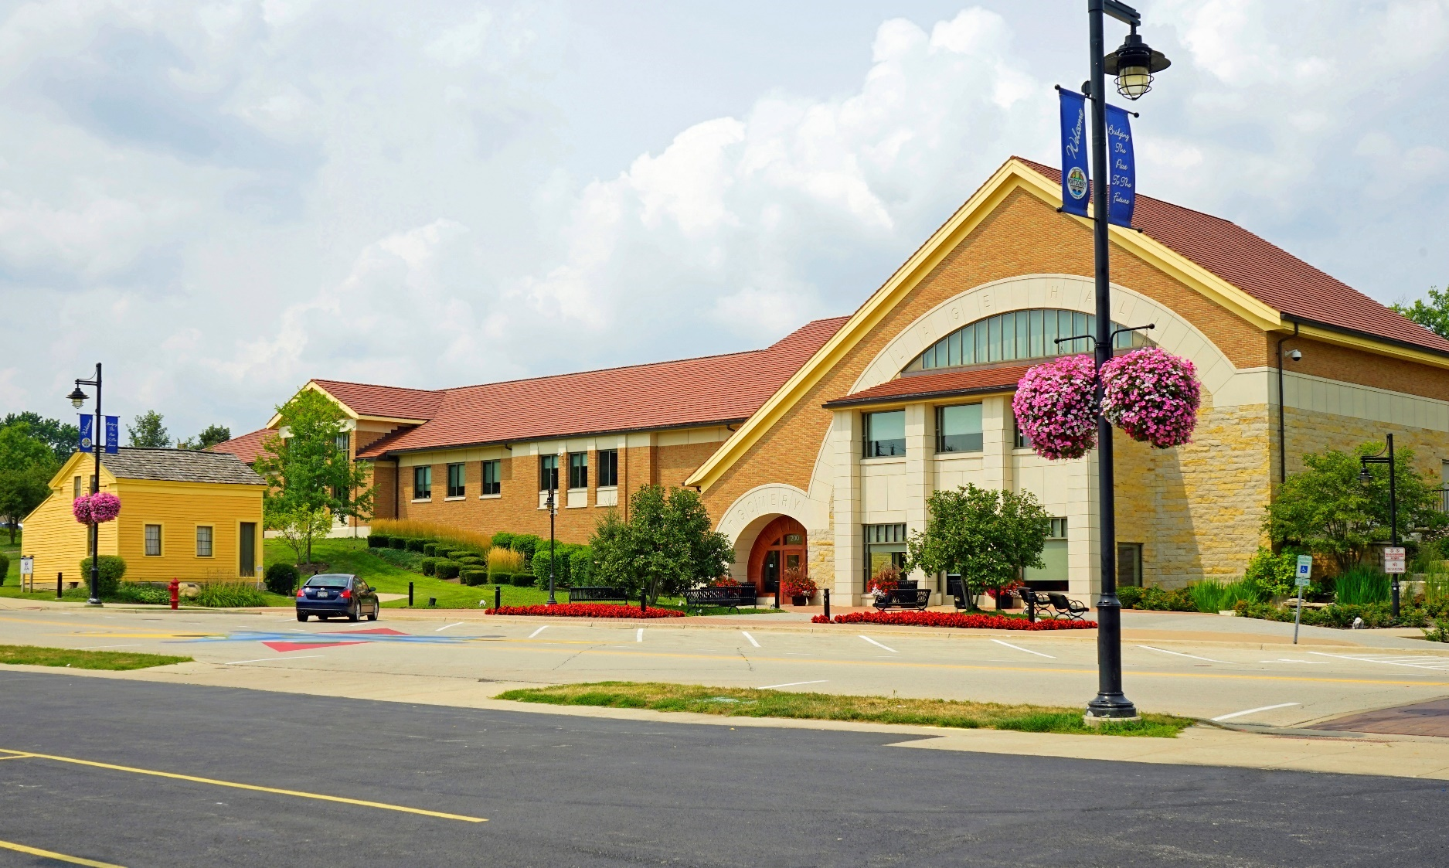
STRATEGIC PLAN
2019-2024

VILLAGE OF MONTGOMERY, ILLINOIS

MESSAGE FROM THE VILLAGE PRESIDENT AND BOARD OF TRUSTEES

As your elected officials, you have placed your trust in us to lead the Village of Montgomery, and deliver on the priorities that matter to you.

We are committed to increasing communication, performance, and efficiencies at all levels while maintaining fiscal responsibility.

This Strategic Plan provides the necessary information and direction for the Board and staff to make rational, informed decisions, allocate resources, provide the appropriate programs and services, and address issues facing the Village, now and into the future.

Limited financial resources have been, and will continue to be an issue for most municipalities. Doing more with less is the new norm, and we must provide strong leadership to transform what we do, and focus on what matters most to our community.

Our community has many needs, both big and small. In order to meet as many of these needs as possible, we must prioritize and focus on projects and actions that are aligned with our strategic goals.

The strengthening of new and existing partnerships with our neighboring communities, Kane and Kendall counties, state and federal representatives and agencies, residents, businesses, and other community organizations will be critical to dealing with strategic challenges that continue to grow in complexity and require innovative solutions devised with the help of those both within and beyond our community.

Our Strategic Plan was developed for our community, resulting in a strong and practical roadmap that clearly articulates the priorities and actions that will help us realize the aspirations we collectively hold for the Village of Montgomery. All of us: Board, staff, residents, businesses, and community organizations have a role to play in achieving our goals.

On behalf of the Village Board, our sincerest thanks to those who have contributed to the development of this plan and the many others who, through their time and efforts, will help us achieve it.

Matt Brolley
Village President



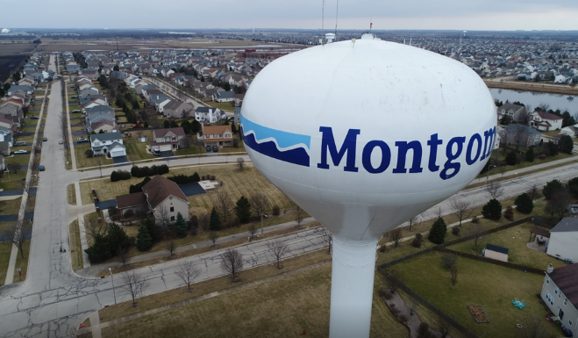

OUR MISSION
Through careful planning and visionary leadership, the Village of Montgomery is committed to providing an excellent quality of life and a high level of municipal services in a fiscally responsible manner to its community.

OUR VISION
We strive to create a safe, inclusive, and financially stable environment for residents, businesses, and visitors, focused on planned economic and residential development, expansion of recreational opportunities, efficient delivery of core services, and effective management of municipal infrastructure.

OUR VALUES

The Village of Montgomery’s Strategic Plan is guided by three fundamental elements: our mission, our vision, and our core values. Our Mission Statement is based on the principles of high quality and continuous improvement. Our Vision Statement presents a compelling future toward which our Strategic Plan is directed. Both our mission and our vision are founded on the following basic values that guide all of our actions and that reflect what we expect from our employees and our elected officials:

Integrity – We will demonstrate the highest degree of honesty, respect, and fairness in our activities to inspire confidence and trust in our government.

Professionalism – We will provide the highest level of knowledge and expertise. We take pride in our work, communicate effectively, project a positive image, and deliver service at the highest standards in every situation.

Responsive – We will be accessible, open-minded, consistent, and understanding. We will offer fast, friendly, flexible, and fair service to all.

Collaborative – We will work as a team, committing to open dialogue with residents, businesses, our neighboring communities, and other levels of government to enhance services and problem solve.

Dedicated – We will be committed to our community and our employees, finding effective solutions to problems that arise as we strive to improve, promote, and help the community where we work and live.

Customer Service – We will focus on listening and supporting the needs of our customers, anticipating and delivering high quality services and ensuring their satisfaction.

STRATEGIC PLAN THEMES
Our Strategic Plan has four primary themes that reflect our Mission and Vision Statements: Quality of Life, Civic Engagement, Economic Development, and Professional Governance.

Each theme is followed by a listing of goals and objectives. Understanding how goals and objectives are defined within the context of this plan is important. Goals are big steps towards accomplishing our mission. They are not easily reached and they are aligned with our values. Goals are broad, value-based statements expressing our preferences for the term of this plan. They specifically address key issues, opportunities, and desires that affect the community. Objectives are smaller steps that are needed to meet these goals. They should be specific, measurable, attainable, timely, and directly related to the goal. Fore each strategic area, actions are also provided. These actions are specific steps refined by Village staff and elected officials for achieving objectives.

Periodic review and adjustment will be necessary over the planning period. We will track our progress through regular reporting on our objectives and actions and they will be incorporated over time into our other planning tools including the annual budget and capital improvement plan.
- QUALITY OF LIFE
  - Develop sustainable, environmentally-friendly infrastructure
    - Use GRC checklist to create a local sustainable, environmentally-friendly program
      - EV charging stations
      - Energy conservation program
      - Solar forum to encourage residential solar
      - Water conservation program
      - Implement LED street light program to reduce electricity costs
    - Develop a recycling education program (improve usage rate)
    - Continue planning for a sustainable, healthy, economical water source
    - Review Village services and adjust/enhance to increase sustainability
  - Enhance visual/aesthetic appeal of Village
    - Work with business community and HOA’s to beautify existing businesses and residential areas
    - Review code enforcement regulations to make sure they contribute to desired aesthetic and then apply them consistently
    - Increase number and type of cultural offerings
    - Enhance pedestrian mobility
      - Continue implementing sidewalk/bike path gap plan
      - Create a path network to allow west side residents to walk/bike to river
    - Establish aesthetic and quality standards
    - Continue working with developers and park districts to develop open space and parks, and promote them to raise resident awareness
    - Increase number and type of public art displays
      - Implement program to display artwork from the high schools attended by Montgomery residents
    - Enhance wayfinding signage throughout the Village
  - Expand and maintain infrastructure
    - Cross reference infrastructure plans
      - Review plans to make sure they work together and are not in conflict (i.e. water main replacement and road rehabilitation plans)
    - Continue working to develop a safe, efficient, multi-faceted transportation network
      - Work with counties to implement Orchard/Route 30 intersection improvements
      - Continue lobbying efforts to promote Route 30 widening
      - Continue working with neighboring communities to promote extension of Metra line into Montgomery
      - Expand PACE program in Montgomery
      - Study feasibility of a Park and Ride program
      - Continue implementing sidewalk/bike path gap plan
      - Create a path network to allow west side residents to walk/bike to river
      - Expand IRP program to the extent allowed by any increase in funding
    - Continue to expand and improve Village water and stormwater systems
      - Continue exploration of regional detention project (TIF #2)
      - Continue exploration of long-term, sustainable water source
      - Implement water meter replacement program
      - Maintain and replace water infrastructure to improve system
    - Implement LED street light program to reduce electricity costs
    - Continue implementation of tree planting/replacement plan to ensure a healthy, diverse tree inventory



- CIVIC ENGAGEMENT
  - Increase resident awareness of Village activities, plans, and opportunities
    - Develop comprehensive communications plan
      - Develop public awareness campaign highlighting Village services and activities
      - Develop public awareness campaign highlighting the Village budget, showing the sources and uses of monies
      - Enhance website and online offerings
        - Redesign Village website
        - Increase information and services available online
          - Water billing and water use information
          - Community Development/property information
      - Increase social media presence
        - Expand information shared on Facebook
          - Videos of Public Works
          - Highlight employees
          - Promote activities of related units (schools, libraries, etc.)
          - Promote local not-for-profits or resident accomplishments
        - Investigate other social media platforms and implement where appropriate
          - Instagram
          - Twitter
      - Expand completeness and use of resident email list
  - Expand opportunities for community to gather and to interact with staff and elected officials
    - Enhance and expand current opportunities
      - Halloween safety event
      - Special Olympics events (Polar Plunge, Cops on Top, Torch Run)
      - PD tours for community groups
      - National Night Out
      - Montgomery Fest
      - River Run
      - Christmas tree lighting
      - Easter egg hunt
    - Create new opportunities
      - Attend HOA, youth groups, service organizations
      - Coffee with a Cop/Coffee with the Chief
      - Shop with a Cop and Beards for Badges program
      - Increase school interaction
      - Citizens Police Academy
      - Cruise night
      - Develop Veteran’s Plaza/gathering place
      - Kayak race
      - Farmer’s market
      - Village open house
      - Increase service project/volunteering opportunities
    - Develop events in different areas of the Village
    - Develop plan to engage residents from every walk and stage of life
    - Expand Village Hall hours for increased customer service
  - Create/Enhance natural features
    - Construct a canoe launch to provide greater access to river
    - Plan for dam modification, including funding
      - Create a whitewater feature for kayaking/canoeing
    - Develop plan for a riverwalk
    - Work with park district to keep river area clean and to control the vegetation
  - Create opportunities for community feedback
    - Conduct community forums
    - Conduct citizen survey regarding services provided by the Village
    - Identify unmet needs of our business community
  - Create and promote a Village identity
    - Community branding
    - Gateway signage
    - Historical nature
    - Determine our story, what makes us unique
    - Create a sense of place
    - Engage with other government units serving Montgomery
      - Library
      - Schools
  - Increase engagement with civic service groups
    - Chamber of Commerce
    - Montgomery Foundation
    - Rotary Club
    - Veteran’s groups

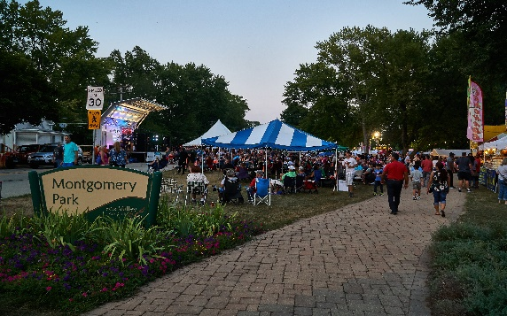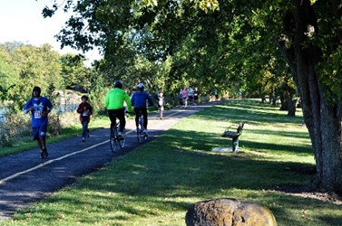

- ECONOMIC DEVELOPMENT
  - Attract and retain array of diverse and attractive businesses
    - Create a business development strategy
      - Redevelopment planning
        - Lyon Metal
        - Caterpillar
      - Attraction planning
        - Industrial – stress food services niche
        - Retail – stress sports venues
    - Determine types of businesses to target
      - Gap analysis
      - Resident survey
    - Develop a dine local program to support restaurants
    - Locate and attract a hotel/banquet facility
    - Develop tools for recruitment and retention
      - Develop list of available Incentives
      - Review permit and development process
      - Review use of TIF districts
        - Plan for establishment of TIF district #3
        - Develop a TIF management plan
        - Develop a TIF marketing plan
    - Increase interaction with businesses and developers
      - Reinvigorate the Douglas Road task force
      - Create a business recognition program
  - Proactively work to create a vibrant downtown
    - Determine desired businesses/attractions
      - Develop list of attractions to bring people downtown
      - Develop list of targeted businesses/developments
        - Restaurants
        - Boutique or niche businesses
        - Professional services
        - Mixed use development
        - High density, high end units
        - Brewery, winery, distillery
        - Entertainment
      - Partner with the library to create an annex at Village Hall
    - Develop planning and financing tools
      - Create a downtown marketing plan
      - Identify funding source – business district or TIF
      - Develop plan for strategic property acquisition
      - Secure investors developers, and brokers
  - Residential
    - Provide housing diversity
      - Age-targeted housing
  - Other
    - Develop plan for future annexations
    - Develop a plan for Village-owned properties
      - Main Street
      - PD campus
    - Review current geographic boundaries and determine opportunities for improvement
    - Review purpose/mission of Chamber and MEDC

- PROFESSIONAL GOVERNANCE
  - Hire, develop, and retain high quality employees
    - Ensure competitive wages and benefits
    - Develop an employee wellness program
    - Create an employee onboarding/orientation program
    - Ensure succession planning
    - Provide ongoing training
      - Customer service training
      - Leadership development
      - Create formalized training program for each position
      - Develop interdepartmental training opportunities
    - Provide opportunities to increase employee engagement and morale
      - Recognize employee accomplishments and milestones
      - Provide equipment and training
      - Personal project opportunities
      - Team building
      - Provide opportunities for professional accreditation
        - ILEAP
    - Other
      - Develop a formal Board orientation process
  - Ensure financial stability and sustainability
    - Enhance and diversify revenues
      - Identify potential new revenue
      - Review fees on a regular basis
      - Increase and diversify tax base
      - Monthly water billing
      - Increase online payment options and use
    - Forecast expenditures and develop cost-saving measures
      - Receive a AAA bond rating
      - Ensure Village ability to meet long-term pension obligations
      - Develop a long-term building maintenance plan
      - Create a community investment plan – 10 years or longer
      - Develop plan for financing and construction of a new Public Works facility
      - Continue funding for scheduled Vehicle and equipment replacement
      - Develop plan to reduce water system loss
  - Work cooperatively with others to reduce costs, achieve efficiencies
    - Increase participation and dialogue – federal agencies
    - Increase participation and dialogue – state agencies
    - Increase participation and dialogue – regional agencies
    - Conduct regular meetings with regional counterparts
    - Strengthen intergovernmental relationships
    - Continue looking for opportunities for resource sharing
  - Use technology to enhance service and assist employees
    - Develop a technology master plan
    - Investigate alternative service delivery methods
    - Implement body-worn cameras
    - Increase GIS capabilities
    - Integrate technology from different departments
    - Maintain technology replacement plan
  - Other
    - Develop a culture of transparency
    - Look for ways to increase efficiency of services
    - Enhance core services
    - Create a high-performance organization
    - Develop performance measures

